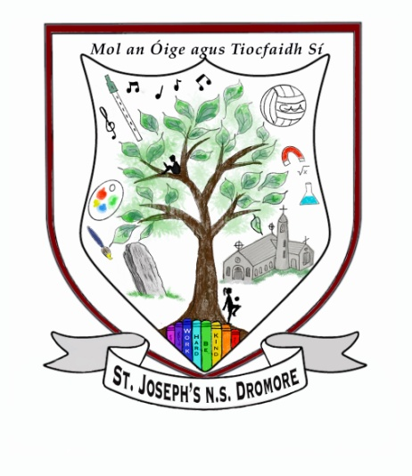 Saint Joseph’s National School

Dromore, Bantry, Co.Cork.

Tel: 028 - 31541

Email: [dromorens@gmail.com](mailto:dromorens@gmail.com)

Principal: Gillian Fitz-Gerald

Acting Principal: Neasa Cotter

# 

# ANTI- BULLYING POLICY

This anti-bullying policy operates in conjunction with the School’s Code of Behaviour, which is used to address isolated instances of anti-social behaviour.

The school has a central role in the children's social and moral development just as it does in their academic development. In school, we work towards standards of behaviour based on the basic principles of honesty, respect, consideration and responsibility. The individuality of each child needs to be accommodated while at the same time acknowledging the right of every child to education in a disruption free environment.

Bullying is defined as repeated aggression, whether verbal, psychological or physical, conducted by an individual or group against others. Examples of bullying include physical aggression, damage to property, intimidation, isolation, name-calling, taunting or ‘slagging’ and any form of cyber bullying. Child to child bullying, teacher to child, intra-staff bullying, parent to staff and parent to child bullying (including a child other than their own) are examples of the areas where bullying may occur.

Isolated instances of aggressive behaviour, which would be dealt with under the Code of Behaviour, would not be described as bullying. However, when the behaviour is systematic and ongoing, it is bullying.

The school acknowledges that there may three parties involved in bullying – those who bully, those who are bullied and those who witness the bullying. Staff and teachers bear this in mind when dealing with bullying incidents and try to support and work with all parties involved.

# Aims of the Policy

* To foster a school ethos of mutual and self-respect.
* To raise awareness of bullying as a form of unacceptable behaviour.
* To outline, promote and raise awareness of preventative approaches that can be used in response to reported incidents of bullying.
* To develop a programme of support for those affected by bullying behaviour and for those involved in bullying behaviour.
* To outline procedures for noting and reporting instances of bullying behaviour.
* To outline procedures for investigating and dealing with incidents of bullying behaviour.

**Child to Child Bullying**

## Stage One

Unless the incident is of a very serious nature, it will be dealt with by the classroom teacher who will talk to the children involved. Teachers respect the need to support the esteem of each party involved in an incident. When a teacher becomes aware that a child is regularly involved in incidents, he/she will start a record of such incidents. The purpose of this record is:

* + to aid memory by recording details of the incident to discuss with parents.
  + for clarity in assessment of the situation.
  + for planning and intervention.

The teacher speaks to all parties individually to clarify the situation. The teacher speaks to all concerned as a group to determine the way forward. A follow-up meeting will take place within two weeks with all parties. Should the action taken at this stage prove not to have resolved the issue, the staff will proceed to stage two.

## Stage Two

The Principal will arrange to meet with the parents of the child who is seen to be bullying and separately with the parents of the victim of bullying. The children themselves may be required to attend part or all of these meetings. The child who is bullying will be monitored - the child’s behaviour, in all areas, is monitored during the day. The teacher keeps a record of what has occurred during the day. All positive behaviour, progress on work etc. will be noted. At the end of the day, the teacher writes his/her own comment and if necessary this will be sent home to be signed by the child’s parent/guardian and returned to school the following day. The purpose of this is to focus as much as possible on the positive qualities and efforts of the child, and to motivate the child to move away from negative behaviour. The child should be able to see that their parents and the school are working together in his/her interest, so the co-operation of the parents is essential. Initially a review of the reports will be carried out on a weekly basis in a meeting with the Principal, teacher, parents and child. The reporting will be continued if needed. A follow-up meeting will take place within a month.

The child who is the victim of bullying will also meet with the Principal and his/her parents. The aim of such a meeting(s) will be to address emotional needs and devise strategies for the child to deal with the bullying. A follow up meeting will take place within a month. This may involve reinforcing the programme being covered in class, or other strategies.

## Stage 3

It is the duty of the school to provide a safe environment for all the children. Should the above interventions fail, and the bullying continues, a programme of appropriate sanctions may be implemented by the Principal in consultation with the parents and the Board of Management. Sanctions implemented will aim to encourage positive behaviour and to support the esteem of the child. These sanctions may include a period of exclusion during which there will be ongoing consultation with the parents to decide on appropriate action(s) to be taken in the best interests of the child. Exclusion for any period of time will follow procedures as laid down in the Rules for National Schools 130(5). Expulsion may be considered in extreme cases according to Rule 130(6),

# Bullying by Adults

In the case of **intra-staff bullying**, Dromore N.S. will adopt the procedures outlined in Section C (c2) of the INTO booklet: ‘Working Together: Procedures and Policies for Positive Staff Relations’. A copy of this document is available for free download on the INTO website.

In the case of **Teacher/SNA – Child bullying,** a complaint should, in the first instance, be raised with the teacher in question by the parent/guardian of the child if possible and then if necessary referred to the Principal. Where it has not been possible to agree a framework for resolution, the matter should be referred in writing by both parties to the Board of Management for investigation.

In the case of **Parent – Teacher/SNA bullying**, the Principal should be informed in the first instance, and if deemed necessary the Board of Management should subsequently be informed in writing.

In the case of **Parent/Visitor to the school – Child bullying,** the complaint should be referred in the first instance to the child’s class teacher and subsequently to the Principal if unresolved.

In the case of **Principal – Parent/Child bullying**, the matter should be raised with the Principal if possible, or referred to the Chairperson of the Board of Management.

This policy will be reviewed annually each academic year.

­­­­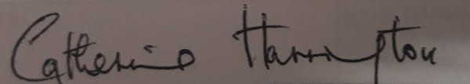______________________________

Catherine Harrington

Chairperson, Board of Management

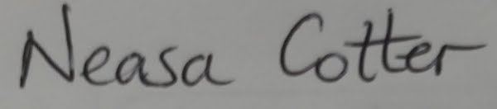__________________________

Neasa Cotter

Acting Principal

Date: 12/10/2023